REFORMED DUTCH CHURCH OF CLAVERACK CEMETERY HISTORICAL WALKING TOUR
Begin the Tour on the West side of the Church (Rte 9H side) at #1 then walk down the hill, via the parking lot exit roadway and enter the Cemetery by the Church sign. The tour graves have an orange reflective driveway marker pole next to them to make them easier to spot (see stop #1). The map below is not drawn to scale.
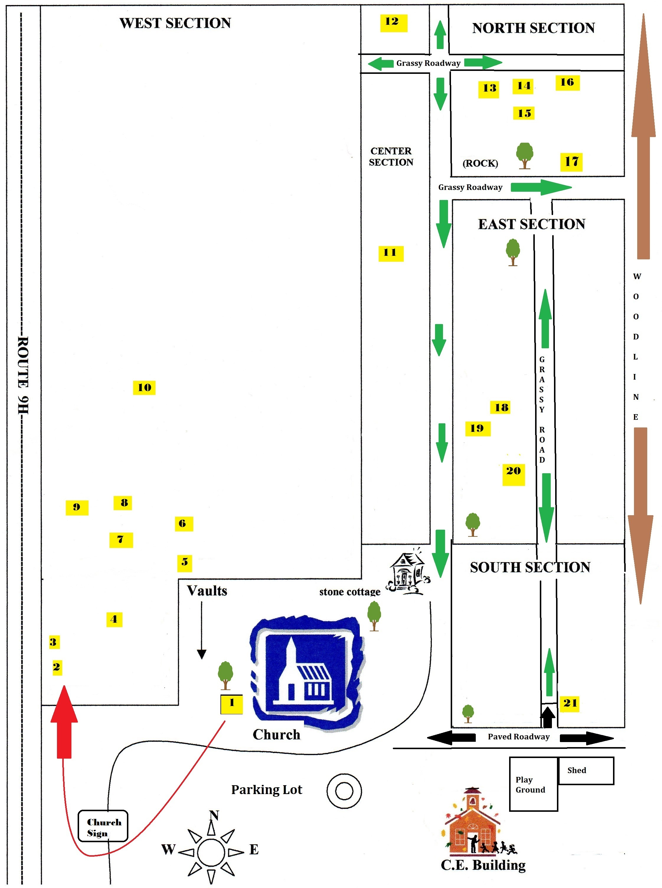
1 | General Robert Van Rensselaer – Fought at Fort Ticonderoga in the battle of Kock’s Field. He was a member of the New York Provisional Congress (1775 – 1777) and the New York State Assembly from (1777 – 1781). He married Cornelia Rutsen and they had 8 children including Jacob Rutsen van Rensselaer (see #7). Robert lived in the Van Rensselaer lower Manor house which is on route 23 and is considered the oldest standing house in the town of Claverack, NY. He died in 1802 and is buried next to the West wall of the church.
Note – There are 57 Revolutionary War Veterans interred in the Reformed Dutch Church of Claverack Cemetery.
2 | Robert Fulton Ludlow – Son of Robert M. and Mary L. Ludlow, he is Robert Fulton’s grandson and was a photographer and painter. His paintings hang in the Daughters of the American Revolution (DAR) Museum, Hudson, NY and Columbia County Historical Society Museum, Kinderhook, NY.
3 | Robert Morris Ludlow – Was the son of William B. Ludlow and Julia Ludlow. He married Mary Livingston Fulton who was Robert Fulton's daughter. Robert Fulton was an American engineer and inventor who is widely credited with developing the 1st commercially successful steamboat, the Clermont. |  |  |  | 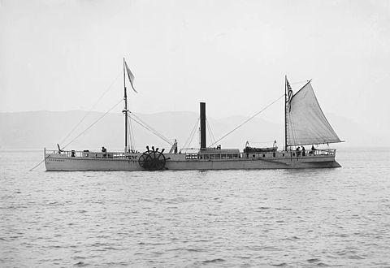
4 | Peter Hoffman – Was president of the board of trustees of the Claverack College which was also known as the Washington Seminary and the Hudson River Institute (see #6). Hoffman purchased the old Claverack courthouse on Rte 23B* and remodeled it into living quarters. When the Washington Seminary was dismantled, he purchased the bell for use on his mansion as a call bell. When the Misses Crane bought the building they presented the bell to the Claverack Union School (Rte 23B*) which is now privately owned. The bell still sits in the cupola.
5 | John Bay – was a lawyer and a New York Assemblymen (1779 – 1795). His house on Route 23B* was taken down and moved to Livingston, NY. The NYS record Hackberry tree (Celtis occidentalis) stood in front of this house and had to be taken down because it was too close to the road.
6 | John Gabriel Gebhard – Pastor of the Reformed Dutch Church of Claverack (1776 – 1826) and founder of the Washington Seminary in 1779 during the American Revolution. In 1830 the school was renamed the Claverack Academy and in 1854 it became the Claverack College, a quasi-military academy for boys, and the Hudson River Institute, a school for girls. Notable alumni include author Stephen Crane and women's rights advocate Margaret Sanger. The school closed in 1902. | 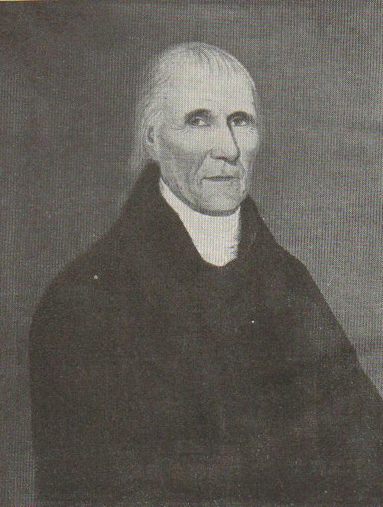 |  |  |  | 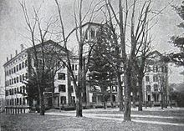
7 | General Jacob Rutsen Van Rensselaer – The son of General Robert Van Rensselaer (see #1). During the War of 1812 he commanded troops that defended New York City. He was the leading Federalist in NYS having been elected to the Assembly nine times between 1800 and 1819, served as Assembly Speaker (1813 – 1815), and as Secretary of State for NYS.
8 | Doctor Walter Vrooman Wimple – the first Claverack physician and a Revolutionary War surgeon.
9 | General Samuel Blatchley Webb – Was a hero of the Revolutionary War battles of Bunker Hill and Brandywine. He also fought and was wounded at the battles of White Plains and Trenton. He was captured by the British at the battle of Long Island and became a prisoner of war for 3 years. He was an Aide-de-Camp to General George Washington and held the Bible for Washington when he took the oath of office as the first President. General Webb was a founder of the Society of the Cincinnati, a fraternal, hereditary society established to perpetuate the achievement of American Independence and "to render permanent the cordial affection subsisting among the officers" of the Continental Army who served in the Revolutionary War. The society's members have included notable military and political leaders, including 23 of the 39 signers of the United States Constitution. He married Catherine Hogeboom who was the daughter of Steven Hogeboom (See #10). They had nine children including James Watson Webb (see #11). |  | 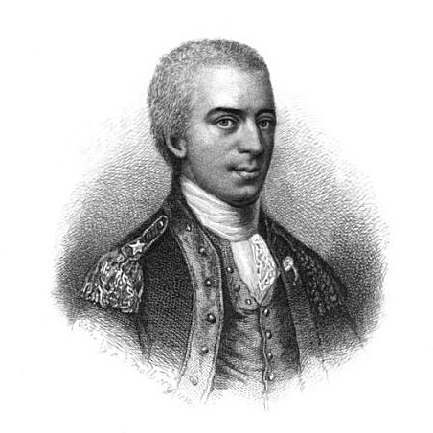
10 | Steven Hogeboom – A Revolutionary War veteran and member of the 14th 16th and 19th sessions of the New York State assembly (1791 – 1796). In 1801 he was a member of the state constitutional convention and was in the New York State Senate for four years.
11 | James Watson Webb – Son of General Samuel B Webb and Catherine Hogeboom. He was an Army 2nd Lieutenant (1819 – 1827) and upon discharge was appointed Chief Engineer for the NY Governor’s staff with the title of Brigadier General. He served as US Minister to Brazil (1861-1868) and during the Civil War visited France asking Napoleon to honor the Union blockade of the Confederacy. He was the publisher and editor of the Morning Courier and New-York Enquirer a daily broadsheet newspaper published in New York City (1829 – 1861) that was closely connected with the rise and fall of the United States Whig Party. He built the mansion house at Red Mills, NY. His son, General Alexander Stewart Webb, received the Medal of Honor during the Civil War battle at Gettysburg. James was so prominent that his body was exhumed and reinterred in the Woodlawn Cemetery, Bronx, NY. |  |  |  |  |  | 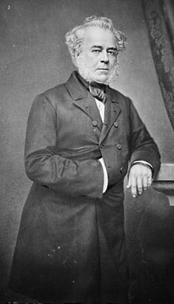
12 | Milton Martin – An owner of Power Martin & Company of Hudson, NY which owned the River Queen, a riverboat used by Abraham Lincoln during the Civil War to meet with a delegation of Peace Commissioners on one occasion and with Generals Ulysses S. Grant & William T. Sherman on another. The boat also transported Civil War soldiers from Hudson, NY to New York City during the war. Martin’s net worth was over 10 million dollars in today’s money by 1870.
13 | William and Elizabeth Clum – Owned a farm in North Claverack where their son John Phillip Clum was born. In 1874 John was appointed Indian Agent for the San Carlos Apache Indian Reservation in the Arizona Territory. During his tenure at San Carlos he established the first Indian Tribal Police and a Tribal Court, forming a system of Indian self-rule. Using only Indian Tribal Police he successfully captured Geronimo without a shot being fired on either side. This gave the US Army a black eye as this was the only time that would ever happen. He later moved to Tombstone, in the Arizona territory, where he published the “The Tombstone Epitaph” and served as Mayor when the infamous gunfight between the Earp brothers and the Clanton faction occurred at the OK Corral. |  |  | 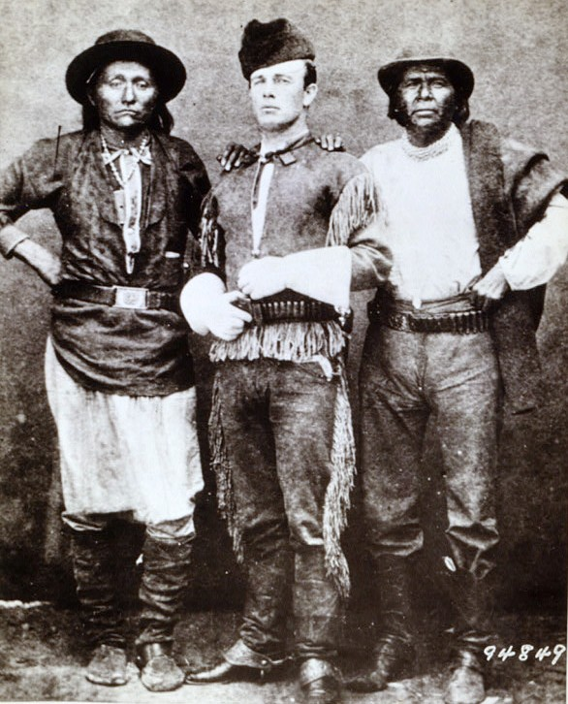
14 | Harriet Livingston Dale – Wife of Robert Fulton (see #3). After the death of Robert Fulton she remarried Charles Dale and moved to England where upon her death she was brought back to Claverack for burial.
15 | Ralph DeLancey Izard – Born in South Carolina to Ralph Izard who was a member of the Continental Congress, a US Senator who served as President pro tempore of the United States Senate in 1794. During the first Barbary War Ralph D. Izard volunteered and took part in the expedition under Lieutenant Stephen Decatur, commanding the ketch Intrepid, which entered the harbor of Tripoli on 2/16/1804 and destroyed the captured U.S. frigate Philadelphia in what Lord Nelson called the most daring act of the age.  After the War, in 1824, while sailing up the Hudson River he became seriously ill and was brought to the Livingston Manor where he died. Harriet Livingston Dale (#14) had him buried in her family plot in the Claverack Cemetery. |  |  |  |  | 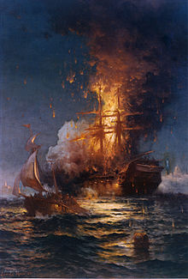
16 | Reverend Alonzo Flack – Principal of the Claverack College and Hudson River Institute (1854 – 1885). Arthur Flack – Son of Alonzo Flack became president of the college after his father died in 1885. He retired in 1900 with the school closing in 1902.
17 | Colin Livingstone – First president of the Boy Scouts of America (1910 – 1925). On May 15, 1960, a granite stone and plaque was placed at the grave by the Albany Fort Orange Boy Scout council members.
18 | Ralph J Studley and the “Puddingstone” – A puddingstone is a conglomerate of stones with small colored pebbles that give the appearance of raisins or Christmas pudding. John Studley emigrated from England to the Boston, MA, area in the 1640’s and may have brought the stone with him. The stone sat on several Studley properties in MA until James Studley moved to Claverack in 1816 bringing the stone with him. James’s son, James Judson Studley, was the first Claverack station agent for the Hudson and Berkshire Railroad (RR) which became the B&A RR. James Judson’s son Albert Studley was the second station agent and in 1889, built a house on Maple Ave., Claverack, moving the stone there. Albert’s son Ralph J. Studley was the third and last station agent and after he passed away the family moved the stone to Studley plot in the Cemetery. |  |  |  |  |  |  | 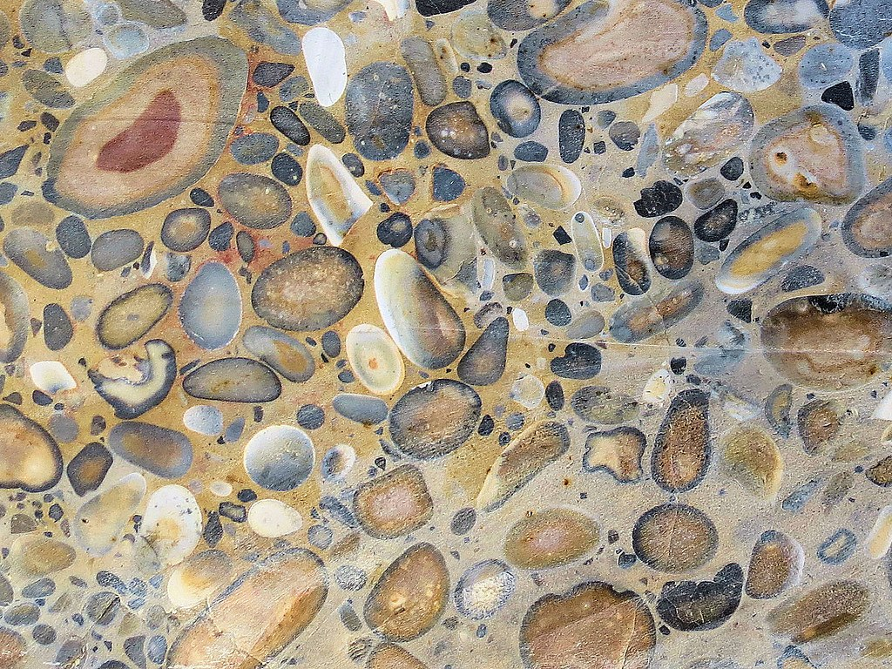
19 | Henry Van Tassel – Was an Air Force Senior Master Sergeant who served in three wars, World War II, the Korean War and Vietnam.
20 | Doctors John Henry Wyckoff and Cornelia Wyckoff – Dr. John Henry Wyckoff was the son of Reverend John Henry Wyckoff, Pastor of the RDCC (1889 – 1892) and was a professor and Dean and of the New York University’s College of Medicine. His daughter, Dr. Cornelia Wyckoff, was an Army 1st Lieutenant who was one of the few women doctors in World War II, she was killed in action.
21 | Leonard and Dorothy Dooren – Leonard was a former Columbia County Supervisor from the Town of Canaan. He was in the US Navy stationed at Pearl Harbor when the Japanese attack occurred. Recognizing the Japanese planes, he shot at them with his pistol. He went on to become a hero having participated in 17 battles in the Pacific Theater. Dorothy "Dolly" Dooren and their baby were sent back to the mainland. During World War 2 they wrote love letters back and forth and at some point a love letter written by Len disappeared only to resurface on eBay where it was sold to a non-family member who returned it to the Dooren family as told by an article printed in the Albany Times Union newspaper.
* Refers to the present day State Route 23B which connects Hudson to Claverack, NY.

